**P4 - Describe what ‘Data Elements’ are and why they are important?**

**Introduction**

In this assignment, I will firstly describe what data elements is. They are different types and I am going to explain and say why they are important. The data element types are the following:

* **Checksum** e.g. **cyclic redundancy check (CRC)**
* **Encapsulation** e.g. frames, packets
* **Datagrams**
* **addresses**
* **sequence numbers**

**Description of ‘Data Elements’**

A data elements is a packet of data that is used to transfer data. A user can use data elements for this and can transfer the data for another user to use. For example, if I completed another work, I can send it to my email and I can access it at home. This is transferring data. This is divided with to classes such as cyclic redundancy check (CRC) and encapsulation. These are the types of elements that is used.

**Cyclic Redundancy Check**

CRC stands for cyclic redundancy check. This is a used within the error detection that encodes the message. This detects any change from the data that has been transferred. This is commonly used on storage devices e.g. USB. Detection of errors is important for any person as if a user was to send work to another person and the error has not been detected, when the person opens it, it would not work for him. CRC does the job within any data block that is transferred.

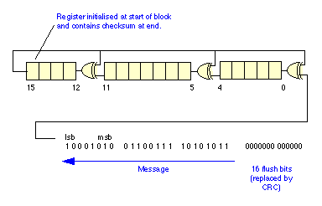

**Encapsulation**

Encapsulation is used within object oriented programming. This is a structure that is used for the first data. When the message is sent to another person, it is encapsulated. This means that it needs to be done for the process to begin. When the data is travelled through the whole OSI model, it goes back to its original form. It is used within object oriented programming.

**Object** **oriented** tends to program ‘objects’. This is used in Java. Many developers use OOP language because they believe that it is suitable for them to use it. The advantage of using OPP is that, as many of other programming languages, it is easy to use. This mimics the real word, as it makes easier for programmers to program new things to grasp. On the other hand, the performance of OOP is very slow. It tends to require more memory than any other programming language. Programmers who tend to be brought up using OOP, it takes longer for them to create.

**Packets**

[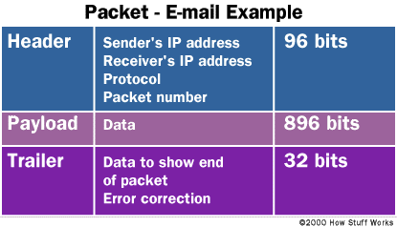](http://www.google.co.uk/url?sa=i&rct=j&q=&esrc=s&source=images&cd=&cad=rja&uact=8&docid=hcjbWo8eMFLg3M&tbnid=j2ZMbzwpGrPkkM:&ved=0CAUQjRw&url=http://computer.howstuffworks.com/question5251.htm&ei=hIqpU_S6EoOZyAT0jICwAQ&bvm=bv.69620078,d.bGE&psig=AFQjCNHcO4lYP5mKVAG0MoiRKFnsdaQZyw&ust=1403706366692042)A packets is a small bit of data of how the document is measured. The data is converted into packets whilst the ‘data’ is being transferred to another user. A packet consists of two kinds of data: control information and user data. When the data is converted, a number of features are being inserted for it to be transferred. The image below shows how the packet is being transferred and how many bits are with it. This is the email and they are a number of procedures for it to be done.

Data packets is used within the Layer 3 of the OSI Layer.

**Datagrams**

|  |  |
| --- | --- |
| **OSI-Layer** | **datagram naming** |
| Layer 4 | data segment |
| Layer 3 | data packet |
| Layer 2 | [Frames](http://en.wikipedia.org/wiki/Ethernet#Layer_2_.E2.80.93_Datagrams) (IEEE 802.3) [Frames](http://en.wikipedia.org/wiki/IEEE_802.11#Layer_2_.E2.80.93_Datagrams) (IEEE 802.11) [Cell](http://en.wikipedia.org/wiki/Asynchronous_Transfer_Mode#Layer_2_.E2.80.93_Datagrams) (ATM) |
| Layer 1 | [Chip (CDMA)](http://en.wikipedia.org/wiki/Chip_(CDMA)) |

A datagrams is a transfer unit that is used within the process of the data. This is not a reliable piece of tool to use whilst the delivery is in process. This is linked with the data as the name suggest, “data”. The datagram will be linked with the protocols so the other user can receive it. Datagram is used within the OSI layers. The datagram is used within the following layers. The image below shows how the datagrams work.

[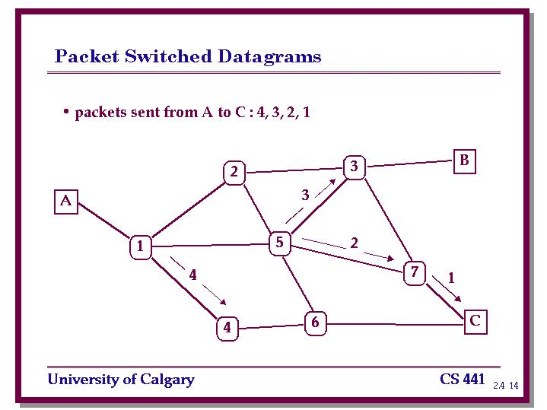](http://www.google.co.uk/url?sa=i&rct=j&q=&esrc=s&source=images&cd=&cad=rja&uact=8&docid=Sz0aIdX83OVZBM&tbnid=AuXUPplF4R2vgM:&ved=0CAUQjRw&url=http://pages.cpsc.ucalgary.ca/~unger/441/lectures/2.4/sld014.htm&ei=m42pU9rFGoH00gXCnYGgCg&bvm=bv.69620078,d.ZWU&psig=AFQjCNH2q4ZzqPZ5_7CBqi_E3m0HtVhN6Q&ust=1403707069569182)

**Addresses**

Addresses is used in the modern computers for the process of transporting data. As the name suggests, it locates the data. It is not the normal address that everyone think however it is the same. As anyone would know, the data that is sent to another person, it would need to be located for the computer. The IP address is located for every computer. Once the data is sent, the user looks for the IP address for another computer. Once the IP address is located, the data is sent to the computer. It says in the name, ‘IP addresses’.

**Sequence numbers**

Sequence number is a process that is used within the transmission control. It is used as a sequence because it allows the user for it to be readable. It allows the user to make sure it travels in bits and when it arrives at its objective, network sequence will allow the user to make sure it is right; it will help the user improve whatever the data.

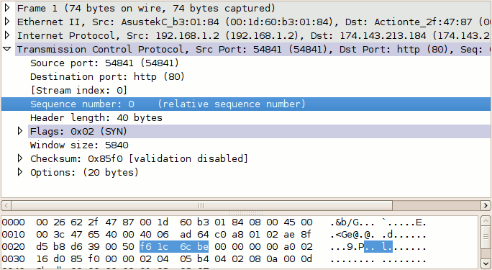

**Keyword**

* **UDP –** This stands for User Datagram Protocol. It is used within the IP layer of the model. This is a core member of the internet that is used in ‘datagram’. It is a protocol that provides services for datagram.